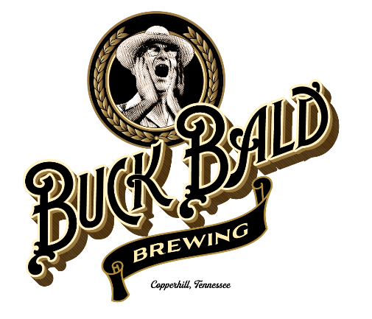

Buck Bald Brewing Battle of the Home Brewers (BBBBHB) Rules and Regulations

# About this event

At Buck Bald Brewing, we love beer. As a former home brewer, I (Patrick) understand the passion that goes into brewing every batch. I always looked forward to the chance to share my beer with others. The purpose of this event is to give local Home Brewers the ability to share and showcase their beers. Our first three BBBBHBs were a huge success. Two winners are now brewing professionally at other local breweries!

# Entry Fee

There is no entry fee for this event. Any home brewer can enter a single beer to be judged by a collection of Buck Bald Brewing staff and local brewers.

# How to Enter

Entries must be personally delivered to Buck Bald Brewing NC or TN May 3 through June 2. No other entries will be accepted. Please bring two bottles of your chosen style of beer (12 oz preferred) labeled with an appropriate Bottle Id Form including your name, address, phone, and email along with the name of the beer and the style. You can find a great example here - <https://www.bjcp.org/docs/SCP_BottleID.pdf>. Please, no more than TWO entries per person!

Additionally, please include a list of ingredients. We don’t need the recipe yet. Just a list of “what’s in there”. See **Judging** for information about why this is important.

# Prizes

We will be awarding prizes to the top three entries. All three winning entries will receive a medal in recognition of their beer. The winner will have an opportunity to brew their beer at Buck Bald Brewing in the Spring or Summer of 2025. The winner will be invited to join us for the brew day.

# Judging

The beers will be judged by Buck Bald Brewing staff and friends. The beer will be judged on a 1-10 scale with 10 being the highest using the following criteria:

**Taste and Mouth Feel – Ultimately what we are looking for is a great tasting beer. Adhering to style is important, but great taste is the key. We’re not beer judges, we’re beer lovers. Give us a beer that tastes great.**

**Appearance – We’re looking for a beer with great color and aroma. Drinking a beer is an experience that starts when you fill a pint and finishes when you order your next one.**

**Appropriateness for Style – Style guidelines exist for a reason. If I order a Pale Ale, I expect it to taste like a Pale Ale.**

**Marketability – Ultimately, we will be using B3 brewing equipment to replicate the winning beer. Since we will be spending money on the ingredients and tying up our brewing equipment for multiple weeks, we need a beer that will sell.**

**\* Availability of Ingredients – Since we’ll be brewing 3BBL of the winning beer, we need to know we have access to all the ingredients. As much as we’d probably love your Schwarz bier brewed with rare German chocolate and European Silver Fir Root, it will probably be cost prohibitive to brew it at B3.**

We’ll combine the scores of each judge to come up with a final score. In the event of ties, the judges will collaborate to make a final decision.

Individual score sheets will not be provided to entrants, but we’ll provide an overall score and any comments by the judges by request.

**\*** The Availability of ingredients category will be judged exclusively by Patrick (who orders the ingredients 😊)

# Winner Announcement

Winners will be announced at an event featuring live music on Sunday, June 9. We’ll work with the winner to schedule a date to brew the winning beer. The winning recipe must be provided within 7 days of the announcement, so we can scale it to a 3BBL batch.

# Additional Notes

This event is FFLB – For Fun and the Love of Beer. This is in no way intended to be a professional evaluation of the individual beer entries. We are not professional judges. We are beer lovers. We hope you will have fun brewing the beer and will appreciate our feedback. We look forward to brewing our winning beer with its creator.

The winning beer will be brewed once, with the permission of the recipe creator. We will not brew the recipe again without the permission of the winner. We will scale your recipe for a 3BBL batch on our equipment. We will try to stay true to the original recipe but may make changes as necessary to optimize the recipe for brewing/sales at Buck Bald Brewing.

We’re looking forward to tasting many great beers!

# Buck Bald Brewing Battle of the Home Brewers (BBBBHB) Judging Form

Appearance (Includes color, carbonation level, aroma, and other visual characteristics)

1 2 3 4 5 6 7 8 9 10

**Notes** ____________________________________________________________________________________________________________________________________________________________________________________________________________________________________________________________________________________________________________________________________________________________________________

Taste and Mouth Feel

1 2 3 4 5 6 7 8 9 10

**Notes** ____________________________________________________________________________________________________________________________________________________________________________________________________________________________________________________________________________________________________________________________________________________________________________

Appropriateness for the Style

1 2 3 4 5 6 7 8 9 10

**Notes** ____________________________________________________________________________________________________________________________________________________________________________________________________________________________________________________________________________________________________________________________________________________________________________

Marketability

1 2 3 4 5 6 7 8 9 10

**Notes** ____________________________________________________________________________________________________________________________________________________________________________________________________________________________________________________________________________________________________________________________________________________________________________

Availability of Ingredients (Patrick Only)

1 2 3 4 5 6 7 8 9 10